|  |  |  |  |  |  |  |  |  |  |  |  |  |
| --- | --- | --- | --- | --- | --- | --- | --- | --- | --- | --- | --- | --- |
| **Literature Review & Elaboration of Problem**  Aabi Zaraat.ai  Version: [01.00]   |  |  | | --- | --- | | Project Code | F23-163B | | Internal Supervisor | Miss Sania Urooj, Dr. M Farrukh Shahid | | External Supervisor | -- | | Project Manager | Dr. M Farrukh Shahid | | Project Team | K200286 – Syed Aun Ali  K200273 – Muhammad Mudabbir  K200441 – Muhammad Fahad Zahid | | Submission Date | 08-12-2023 (DD-MM-YYYY) | |

Document History

|  |  |  |  |
| --- | --- | --- | --- |
| ***Version*** | ***Name of Person*** | ***Date*** | ***Description of change*** |
| 01.00 | Syed Aun Ali | 06-12-2023 | Initial Commits |
|  |  |  | Added Text References |
|  |  |  | Finalized Formatting |
|  |  |  | Refinement On Approval |
|  |  |  |  |
|  |  |  |  |
|  |  |  |  |

Distribution List

|  |  |
| --- | --- |
| ***Name*** | ***Role*** |
| Miss Sania Urooj, Mr. Farukh Shahid | Internal Supervisor |
| Dr. M Farukh Shahid | Project Manager |
|  |  |

Document Sign-Off

|  |  |  |  |
| --- | --- | --- | --- |
| ***Version*** | ***Sign-off Authority*** | ***Project Role*** | ***Sign-off Date*** |
| 01.00 | Mr. Farrukh Shahid | Supervisor | 08-12-2023 |
|  |  |  |  |
|  |  |  |  |
|  |  |  |  |
|  |  |  |  |
|  |  |  |  |
|  |  |  |  |

#### Table Of Contents

1. Abstract 6

2. Background and Justification 8

3. Problem Statement 11

4. Literature Review 14

5. Appendices 24

6. References & Bibliography 24

# Abstract

In the domain of research and development, our FYP project introduces an innovative mobile application that is tailored for business-to-business (B2B) users. Via the use of smart phone, users can seamlessly employ their device cameras to identify and classify diverse soil types and fish species that is locally found across Pakistan. In case of soil classification, our mobile app allows users with comprehensive insights into the identified soil's properties. It provides detailed information on the recommended fish species, accompanied by precise ingredient proportions details (fish hydrolysate). This amalgamation enhances protein levels within the specific soil, resulting in an optimal soil health. In the context of fish classification, our app will offer all the relevant details of the fish that includes fish health, freshness, and the presence of any potential diseases. Moreover, the app also instructs user with precise blending instructions, specifying the optimal combination of fish species, other ingredients, and suitable soil types for achieving the best outcomes. Harnessing machine learning, computer vision, and artificial intelligence, our project revolutionizes agriculture and aquaculture, contributing to sustainable practices in Pakistan.

Pakistan's agricultural landscape faces the challenge of enriching nutrient-depleted soil for sustainable farming. Our research addresses this through a mobile application utilizing machine learning, computer vision, and AI, which allows comprehensive classification and analysis of fishes as well as soil. The fishes are categorized as halal and haram, and these fishes play a pivotal role in extracting essential nutrients for organic fertilizer production. The app provides detailed information on fish species, guiding users in wise and informed decisions for soil enrichment. Significantly, the research aims to automate nutrient extraction processes, promoting widespread adoption of organic farming and moving away from continuous use of harmful chemical fertilizers. The application's insights into fish-soil compatibility empower users and helps in contributing towards sustainable agriculture in Pakistan.

**Keywords:** Artificial Intelligence, Deep Learning, Computer Vision, Agriculture, Aquaculture, Economical, Sustainable.

* Following Roadmap diagram represents the workflow of this Literature Review Document:

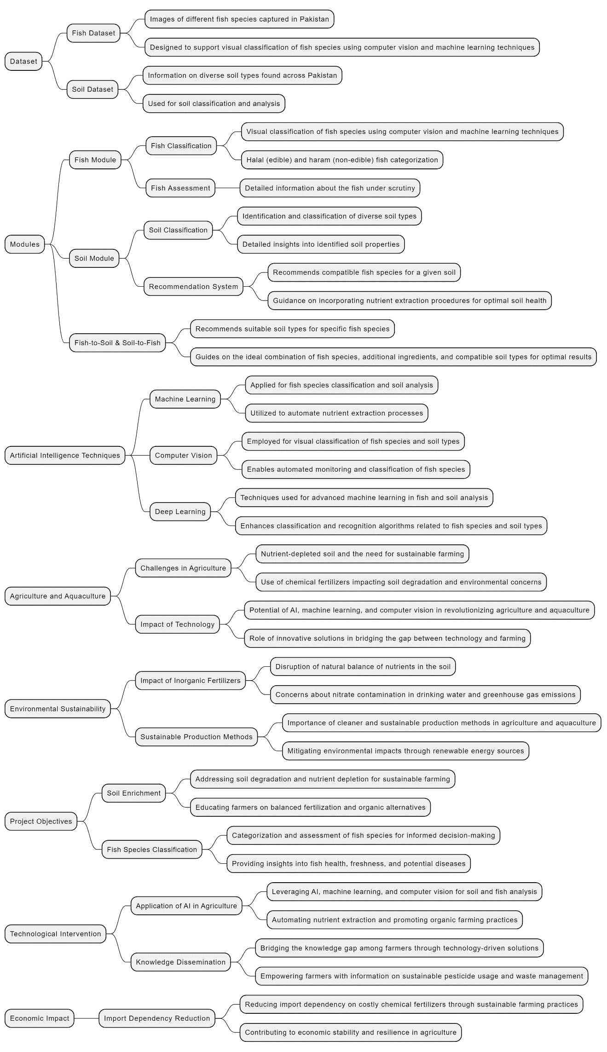

# 

* 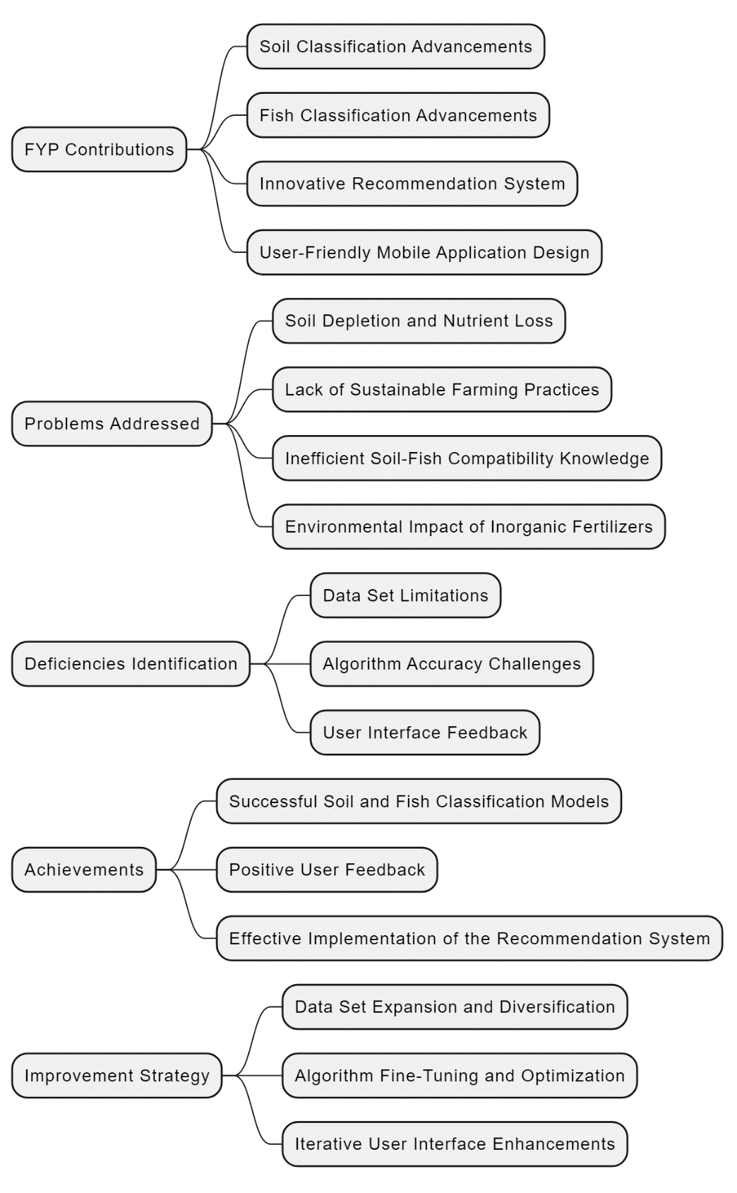Following diagram encapsulates the contributions made in our FYP Aabi Zaraat.ai. The visual representation highlights our achievements, addresses identified deficiencies, and provides a clear overview of the problems tackled:

# Background and Justification

In recent years, Artificial Intelligence (AI) has improved significantly due to many developments and advancements in the field [1]. Many mobile applications are being built in the domain of AI that are accessible through our trusty smart phones. The usability of AI is further extended by techniques such as Deep learning (DL) and Computer Vision (CV) [2][3], which happens to be our domain of research and development. In our project, we will be focusing on the intersection of modern available technological prowess and the vital sectors of agriculture and aquaculture in Pakistan by harnessing the extended techniques AI has to offer. The backbone of Pakistan's economy is agriculture [4], and as time progresses, the agricultural system of Pakistan calls for an innovative solution that can bridge the gap between technology and farming. This need forms the backdrop for our project. The current agricultural landscape of Pakistan faces a critical challenge of enriching nutrient-depleted soil for sustainable and organic farming practices. Traditional farming methods, coupled with the depletion of essential nutrients in the soil [5], necessitate an innovative approach to revolutionize agriculture. In response to this, our research introduces a mobile application that leverages modern technologies—specifically, machine learning, computer vision, and artificial intelligence.

Existing agricultural practices in Pakistan often rely on chemical fertilizers, leading to soil degradation and environmental concerns. Over-reliance on inorganic fertilizers has disrupted the natural balance of nutrients in the soil, leading to nutrient imbalances and reduced soil quality. Inorganic fertilizers have a higher potential for leaching compared to organic fertilizers, posing concerns about nitrate contamination in drinking water. They also contribute to the emission of nitrous oxide (N2O), a potent greenhouse gas and substantial carbon dioxide (CO2). This can result in habitat destruction, deforestation, and biodiversity loss. Cleaner and more sustainable production methods, such as utilizing renewable energy sources, are imperative to mitigate these environmental impacts. [6]

The proposed mobile application addresses this issue by providing a user-friendly interface that allows farmers and agriculture enthusiasts to identify and classify diverse soil types and fish species through their smartphone cameras. This technology-driven solution builds upon previous research in the field of agriculture, aiming to bridge gaps and overcome limitations.

Picture a mobile application that uses the power of smart phone's camera to revolutionize two critical aspects of nutrient extraction: soil classification and fish assessment. Fish organic fertilizer, a nutrient-rich substance produced from fish waste and by-products, serves as a valuable source for soil conditioner, enhancing plant growth and soil health. We aim to leverage its potential to improve agricultural activities on poor soil. This application is specifically designed for business-to-business (B2B) users, opening up a plethora of possibilities in the agricultural landscape of Pakistan. When the app is being used for soil classification, it becomes a knowledgeable ally for farmers and soil inspectors. Along with identification of soil, the app offers great insight into each soil type's unique properties. Moreover, the app also offers recommendation of the most compatible fish species for a given soil. The application also provides the user with precise instructions on the incorporation of nutrient extraction procedures, a strategic move to boost soil protein levels and enhance overall soil health*.*

Moving on to the next use case of our project, which is fish classification. The halal (edible fishes) and haram (non-edible fishes) dataset that will be used to train the model for fish classification will be collected locally (commonly found in the fish markets of Karachi), just like the soil dataset. The application will provide extensive information about the fish under scrutiny. The application will also guide the user on the ideal combination of fish species, additional ingredients, and compatible soil types to achieve optimal results.

With this technologically innovative project, we aim to practically create a farming companion. The application will simplify the complexities of agriculture while automating the nutrient extraction procedures. With just a single tap on the screen, users can access a realm of agricultural insights, making their farming endeavors smarter, more efficient, and undoubtedly more accessible. The core of our project is to promote intelligent and sustainable agricultural practices. With our project, this goal is well within reach.

# Problem Statement

Pakistan's agriculture faces a critical juncture marked by soil degradation, economic strain, knowledge deficits of local farmers, and environmental hazards. Rampant use of chemical fertilizers leads to soil degradation and nutrient depletion, impacting yields. The lack of knowledge among the local farmers hinders informed decision-making, making the agricultural challenges even worse. Economic fragility of Pakistan, which is further intensified by import dependency on costly chemical fertilizers, threatens the nation's economic stability even more. The unstable agricultural yields on certain soils and environmental consequences further compound the multifaceted issues. Addressing these challenges requires a comprehensive strategy involving education, economic reforms, policy changes, and a shift towards sustainable practices, ensuring a resilient agricultural future for Pakistan. This comprehensive problem statement seeks to unravel the multifaceted issues that are affecting Pakistan's agriculture. Our project Aabi Zaraat.ai takes all of these challenging factors into account and provides an AI-driven automated sustainable assistance to people involved in this process via many of its innovative and helpful use cases. Following is a list of problems we will be covering along with how our project will help solve them:

**Soil Degradation and Nutrient Depletion:**

The relentless use of chemical fertilizers, once hailed as the catalyst for increased yields, has become a one of the leading causes of soil nutrient depletion in Pakistan’s soil. The balance of essential elements in the soil has been disrupted, leading to a number of avoidable consequences—nutrient imbalances, reduced soil quality, and compromised fertility. This poses a severe threat to the sustainability of farming practices in Pakistan. Our smart app can help the farmers understand more about the soil they own and intend to practice agriculture/farming on it. Via the use of camera, the user will be given complete details of the captured-in-image soil along with the recommendation what kind of organic fertilizer/products (derived from aquaculture of Pakistan in our case) is best suited for their soil.

**Uninformed Decision-Making and Knowledge Deficit:**

The absence of informed decision-making casts a long shadow on the agricultural landscape of Pakistan. The actual owners of the land, the farmers of Pakistan, usually find themselves navigating the complexities of agriculture without the right knowledge. Their farming knowledge is limited to outdated practices, unknowingly contributing to soil degradation and reduced crop yields of their own land! Bridging this gap requires access to modern agricultural techniques and modern knowledge. Since our application provides detailed analysis of the soil and fishes along with proper guidance in enrichment of soil with nutrients, the interacting farmer can easily access it and incorporate the global standard knowledge into his/her daily farming practices. This way our application will spread the knowledge of globally recognized and accepted farming practices into local uninformed farmers of Pakistan.

**Economic Downturn and Import Dependency:**

Beyond the fields, the repercussions of agricultural mismanagement resonate through the economic corridors of Pakistan. The nation has developed a heavy reliance on imported fertilizers, which are very expensive. Despite the availability of locally sourced, sustainable alternatives, the economic situation of Pakistan is strained by the escalating costs of imported solutions. This economic vulnerability jeopardizes Pakistan’s ability to invest in sustainable agricultural practices. Our project encourages using natural ways to make soil better. Pakistan is one of those countries that have access to sea and Pakistan itself does make use of this via its aquaculture (whose potential usually gets overlooked greatly). Our project show farmers how to get nutrients from locally available fish, which is cheaper and better for our economy. This way, we don't have to depend on other countries for expensive fertilizers. This will also be easy on the pockets of the actual practicing farmer.

**Agricultural Yield Decline and Food Insecurity:**

As the soil loses its vitality, the results appear in the form of decline in agricultural yields. The diminished productivity of crops not only threatens the livelihoods of farmers but also create a food insecurity concern among the nation. The interconnectedness of agricultural yield, economic stability, and soil health forms a great concern that demands immediate attention. Lack of crop rotation and carbon neutrality in soil (instilled by the heavy use of chemical fertilizers) are some of the leading causes of soil nutrient decline in Pakistan. We need a way to farm that keeps the soil healthy. Our app promotes sustainable farming that makes locally available natural resources as its core base. It tells farmers how to use natural methods to make the soil better, like using nutrients from fish (organic farming).

**Environmental Impacts:**

The environmental footprint of agricultural mismanagement extends far beyond the boundaries of farmlands. The misuse of chemical fertilizers introduces harmful substances into water sources, contaminating groundwater and greatly threatening aquatic ecosystems. The air becomes victim of unintended consequences, with nitrogen-based gases released from fertilizers contributing to air pollution and climate change. The environmental toll is a silent consequence of our current improper agriculture procedures. Our project makes sure the soil experience carbon sequestration, helping it retain the natural organic carbon content in soil and protecting it from irreversible damage. It also promotes resilience since organic farming promotes the ability of soil to retain water and natural nutrients, helping in the extreme cases like drought or floods. Our application tackles all sorts of disruptive global stressors farmers face via the use of organic farming.

**Aquaculture Potential and Untapped Resources:**

Amidst the challenges lies an unexplored reservoir of potential—the aquatic resources of Pakistan. Aquaculture, often overshadowed by traditional farming practices, emerges as a source of natural alternative raw material for products to be used in agriculture of Pakistan. The local aquaculture industry, if harnessed effectively, could provide sustainable and cost-effective alternatives for soil enrichment. Integrating aquaculture into mainstream agricultural practices presents an opportunity to break free from the chains of import dependency and nurture the soil back to health. This is one the goals of our project as it emphasizes greatly on this.

**Importance of Addressing the Problem:**

The urgency to address these interconnected issues cannot be overstated. The spiral of soil degradation, economic strain, and environmental degradation poses a direct threat to the nation's food security, economic stability, and ecological well-being. These issues require immediate proper attention, and the solutions lie not only in scientific advancements but also in fostering a culture of informed and sustainable agricultural practices. Aabi Zaraat.ai is one of many steps taken in the right direction leading to Pakistan revitalizing its soil through natural resources.

**Difficulties and Challenges in Addressing the Issues:**

**Lack of Awareness and Education:**

Farmers lack knowledge about optimal farming practices, and gaining their trust in new technology is a hurdle. We intend to deal with this via showcasing the app's simplicity and usefulness, actively seeking farmer feedback for continuous improvement. Creation of Agri-aqua culture centric knowledgebase and collection of local datasets was also challenging since local people (related to this industry) lacks sufficient and correct knowledge when it comes to optimal farming practices. However, with some persuasion, they agreed to take some time out from their daily work and collaborated with us in creating a correct working model of our app.

**Economic Constraints:**

The initial resistance to sustainable practices often stems from economic constraints. Introducing innovative financing models, subsidies for sustainable practices, and incentives for transitioning to organic and aquaculture-based solutions can help alleviate the economic burden on farmers. Our application can teach them how exactly they can achieve this.

**Cultural Resistance to Change:**

In a landscape shaped by tradition, convincing farmers to embrace change can be quite a challenge. Hence the reason why our application is Business-to-Business oriented (B2B). They will be responsible for dealing with the delicate balance of education, cultural sensitivity, and community engagement. Empowering local leaders and influencers to champion sustainable practices within their communities can pave the way for widespread acceptance.

Aabi Zaraat.ai holds tremendous potential in addressing critical agricultural challenges in Pakistan. By navigating these obstacles and providing a solution through our innovative app, we are contributing to a transformative change in sustainable farming practices. The collaborative effort of farmers, policymakers, scientists, and environmentalists, along with the power of technology, in creating our application can pave the way for a resilient and sustainable agricultural future of Pakistan.

# Literature Review

In this section, we delve into the existing body of knowledge related to the agricultural challenges faced in Pakistan. Examining the current state of soil degradation, nutrient depletion, and unsustainable farming practices, we highlight the critical issues that necessitate innovative solutions. By providing context and insight into the prevailing problems, this literature review sets the stage for the significance of our research.

* 1. *Soil Health and Agricultural Practices:*

This subsection explores studies and findings related to soil health and conventional agricultural practices in Pakistan. We review research on the impact of chemical fertilizers, traditional farming methods, and their contribution to soil degradation. Understanding the intricacies of soil management practices is crucial for formulating effective strategies, and this review aims to synthesize existing knowledge in this domain.

The economic significance of land degradation in Pakistan is highlighted in the document, emphasizing the importance of maintaining a growth rate of more than five percent in the agriculture sector for rapid national income growth, macroeconomic stability, employment opportunities, and poverty reduction. The Medium-Term Development Framework (MTDF) 2005-10 emphasizes the crucial role of the agriculture sector in the national economy and envisions an increase in agricultural growth to achieve these economic objectives. The document further discusses how the degradation of natural resources, including land, contributes to the vulnerability of farmers, particularly in dryland areas. It points out that inadequate natural resource management has led to low agricultural productivity, poor living standards, and limited opportunities for economic advancement. Additionally, it emphasizes that sustainable and efficient management of natural resources is essential for improving productivity and reducing poverty in rural areas. The impact of land degradation on agricultural productivity, rural livelihoods, and national economic growth is underscored, signaling the need for effective measures to address this issue. Furthermore, the document highlights the importance of incorporating the perspectives and participation of local farmers and communities in the planning and implementation of policies and interventions to address land degradation. This inclusive approach is seen as essential for creating awareness, promoting sustainable land management practices, and empowering those most affected by land degradation to participate in decision-making processes. [4]

Based on the given ICARDA Survey [4], the commonly found soil types in Pakistan are:

1. Clayey

2. Loamy

3. Sandy

4. Calcareous

5. Silt-loam

6. Moderately Calcareous

7. Silty clay loam

8. acidic (above 2100 altitude)

9. Calcareous at lower altitude

According to the survey [4], common reasons found for the land degradation in Pakistan are:

1. *Water erosion:* The impact of erosion caused by water, particularly in areas with intense summer rainfalls and melting snow, affecting approximately 11 million hectares of land.

2. *Wind erosion:* It is mentioned that overgrazing, deforestation, and water erosion have led to significant land degradation, affecting around 24 million hectares, particularly in dryland and upland areas such as Baluchistan, NWFP, and parts of Punjab.

3. *Depletion of soil fertility:* The removal of topsoil has resulted in declining soil fertility, impacting the production of forage, fodder, fuelwood, timber, and grains.

1. *Deforestation:* Its impact has been discussed on river basins in Sindh and Punjab, leading to widespread land degradation affecting approximately 11 million hectares.
2. *Livestock Grazing Pressure:* Overgrazing is identified as a significant contributor to land degradation, particularly in areas affected by deforestation, water erosion, and wind erosion.
3. *Loss of Biodiversity*: It is noted that the increasing human and livestock population has put enormous pressure on natural vegetation, leading to a decrease in biodiversity in various agro-ecological regions.
4. *Water logging and Salinity:* Poor irrigation practices have led to water logging and salinity, affecting approximately 14 million hectares of land.
5. *Drought and Flooding:* The recurring challenge of drought in arid and semi-arid regions of Pakistan has caused adverse effects on agriculture and human activity, as well as the significant impact of flooding during monsoon seasons.
6. *Socio-economic constraints:* The survey highlights the economic impacts of land degradation policies, coping strategies, and technological interventions, emphasizing the importance of addressing socio-economic factors in managing land degradation and sustainable agricultural practices.
7. *Soil Pans:* The survey mentions the formation of a dense "plough pan" due to continuous use of traditional ploughs, hindering water penetration and plant root growth, particularly pronounced in silty soils.
8. *Soil Nutrient Degradation:* The survey pointed out the deficiency of nitrogen, phosphorus, potassium, Sulphur, and other nutrients in cultivated soils, particularly in irrigated sandy and loamy soils, highlighting the causes of nutrient loss such as leaching, continuous cultivation, and a hot and arid climate.

The following text by “The Nation” suggests that the lack of knowledge is endangering our Food security, it states: “The recent report by the Sindh Food Authority (SFA) exposes the alarming persistence of cultivating vegetables with sewage water on the outskirts of Karachi, despite court directives. This poses severe health risks, with experts warning of diseases like hepatitis and cancer due to the absorption of sewage chemicals by crops. The lack of enforcement and coordination among authorities is a significant factor in this ongoing issue. The SFA's identification of problematic areas is commendable, but stringent regulations, penalties, and collaboration with experts are urgently needed. Establishing food laboratories in universities, as seen in the accord with the University of Karachi, is a wise step to ensure food quality. Consumer caution, support for local farmers following proper practices, and awareness about risks are essential. Government action, strengthened regulatory frameworks, and collaboration with experts are crucial, alongside individual responsibility in making informed and sustainable choices.” [7]

IIPS has listed several key benefits for Pakistan if sustainable agriculture is practiced, some of them are [8]:

1. Improved Food Security: Sustainable agriculture practices lead to higher and more stable crop yields over time, ensuring a consistent food supply for Pakistan's growing population.

2. Economic Growth: By adopting sustainable farming techniques, farmers can reduce input costs, increase their income, and access premium markets for organic and sustainably produced goods.

3. Environmental Conservation: Sustainable agriculture helps protect ecosystems, reduce greenhouse gas emissions, and conserve water resources, contributing to long-term environmental sustainability.

4. Resilience to Climate Change: Diversified cropping systems and climate-smart practices make agriculture more resilient to the effects of climate change, reducing vulnerability to extreme weather events.

5. Enhanced Livelihoods: Sustainable agriculture practices can improve the well-being of rural communities by creating employment opportunities and improving access to nutritious food.

These were the background that necessitate innovative solutions, and we are providing exactly that with our work Aabi Zaraat.ai.

* 1. *Soil Health and Agricultural Practices:*

This subsection explores studies and findings related to soil health and conventional agricultural practices in Pakistan. We review research on the impact of chemical fertilizers, traditional farming methods, and their contribution to soil degradation. Understanding the intricacies of soil management practices is crucial for formulating effective strategies, and this review aims to synthesize existing knowledge in this domain.

Soil is an essential component for sustaining life. It provides crucial ecological services. Managing soil health is vital for biodiversity and sustainable agriculture. The physicochemical and biological properties of soil regulate its health. While modern agriculture heavily relies on fertilizers, their use poses threats to the environment. Chemical fertilizers enhance crop productivity and soil fertility but have serious detrimental effects. Continuous usage leads to a decline in soil organic matter, hardening of the soil, pollution, and reduced nutrient content, posing environmental hazards. The exclusive use of chemical fertilizers weakens microbial activity, alters soil pH, increases pests, and contributes to greenhouse gas emissions. This persistent use influences soil biodiversity and overall well-being, highlighting the need for sustainable agricultural practices. [9]

As per study conducted by Pakissan regarding “Fertilizer And Environmental Pollution In Pakistan”, the potential consequences of over-application of fertilizers in Pakistan include various harmful negative effects. These consequences are:

*1. Environmental Pollution:* Over-application of fertilizers can lead to environmental pollution through the leaching of nitrogen into groundwater, rivers, lakes, and coastal waters. This pollution can also result in the eutrophication of water sources, causing algal blooms, heavy growths of aquatic plants, and deoxygenation, which can harm aquatic organisms.

*2. Accumulation of Heavy Metals:* Phosphorus fertilizers can lead to the accumulation of heavy metals such as cadmium in agricultural products. Over time, the continuous use of phosphatic fertilizers can result in the accumulation of cadmium in crops, posing a threat to human health if consumed.

*3. Gaseous Loss and Air Pollution:* Excessive use of nitrogenous fertilizers can result in gaseous loss of nitrogen into the atmosphere, leading to the release of carbon dioxide, ammonia, and oxides of nitrogen. These pollutants can affect human health, contribute to respiratory diseases, and potentially harm the ozone layer.

*4. Human Health Concerns:* Cadmium accumulation in agricultural products due to the use of phosphorus fertilizers can result in human health problems such as kidney damage, bone deformities, and cardiovascular issues.

*5. Agricultural Sustainability:* Over-application of fertilizers can disrupt the ecological balance, upset the existing soil fertility, and lead to unstable yield levels. This can impact long-term agricultural sustainability and the quality of food and fodder. It is important to consider these potential consequences when discussing traditional farming methods in Pakistan and the shift towards chemical fertilizer use. Efforts to raise awareness about balanced fertilization, soil testing, and the proper use of fertilizers can help mitigate these harmful effects and promote sustainable agricultural practices.

*6. Cadmium Accumulation:* The use of phosphate fertilizers containing cadmium can result in the accumulation of cadmium in crops. This poses a potential health risk, as high levels of cadmium consumption from contaminated crops can lead to human health problems.

The document suggests the importance of soil testing before the application of fertilizers to determine specific crop nutrient needs, as blanket fertilizer recommendations may not be suitable for all crops or soil types. It emphasizes the need for local research to understand soil and crop conditions, balanced fertilization, and the use of organic alternatives such as animal manure and fish compost. The document also stresses the importance of educating and engaging extension workers to provide farmers with information, demonstrations, and guidance on proper fertilizer use and other agricultural practices. Additionally, it highlights the need for ensuring the availability of appropriate fertilizers based on soil types and crop demands, at the right time. These suggestions are aimed at promoting sustainable and efficient fertilizer use to mitigate the negative environmental and health effects associated with over-application. [10] Aabi Zaraat makes sure the user understands his/her owned soil in more depth and make informed decision about it. With ease of access to knowledge, farmers will be provided with proper guidance on how to make use of local resources for sustainable farming. Our app understands these intricacies of soil management practices and performs the crucial task of formulating effective strategies.

* 1. Technological Interventions in Agriculture:

Here, we examine literature on the integration of technology, particularly machine learning, computer vision, and artificial intelligence, in addressing agricultural challenges. By analyzing previous research in similar domains, we build a foundation for the application of modern technologies in soil analysis, nutrient extraction, and sustainable farming practices.

Some of the applications of deep learning in aquaculture include fish classification, fish counting, fish behavior monitoring, fish fillets defect detection, shrimp disease research, shrimp freshness detection, pearl classification, scallop counting, coral species classification, activity monitoring of cold water coral polyps, jellyfish detection, aquatic macroinvertebrates classification, phytoplankton classification, trend prediction of red tide biomass, dissolved oxygen content prediction, chlorophyll-a content prediction, temperature prediction, marine floating raft aquaculture monitoring, obstacle avoidance in underwater environments, and virtual fish grasp.

Deep learning is utilized in aquaculture for fish classification and fish behavior monitoring in various ways. For fish classification, convolutional neural networks (CNN) are commonly used to automatically extract features from fish images, enabling accurate classification of different fish species with high accuracy. This is achieved by training the CNN model on large datasets of fish images, allowing it to learn and differentiate between various visual characteristics of different fish species. Additionally, deep learning can also be combined with other technologies such as virtual reality and robotics to further enhance the classification and detection of fish in aquaculture environments. In terms of fish behavior monitoring, recurrent neural networks (RNN) are often employed to analyze video clips capturing different fish behaviors. RNN models are capable of learning and recognizing patterns in temporal data, making them suitable for detecting and classifying different fish behaviors based on video footage. By training RNN models on labeled video clips of normal and unusual fish behaviors, it becomes possible to achieve high accuracy in detecting, localizing, and recognizing specific fish behaviors. Additionally, the use of multimodal deep learning techniques allows for the integration of sensor data (such as motion sensors) with video data to provide a more comprehensive analysis of fish behavior in aquaculture environments. Overall, deep learning techniques, particularly CNN for fish classification and RNN for fish behavior monitoring, have demonstrated promising capabilities in enhancing the efficiency and accuracy of aquaculture operations. [11]

Based on the document FISH-PAK, the technological interventions, particularly in the fields of machine learning, computer vision, and artificial intelligence, have been employed in the agriculture of Pakistan through the development of the Fish-Pak dataset. This dataset consists of images of different fish species captured in Pakistan, and it is designed to support visual classification of fish species using computer vision and machine learning techniques. The dataset serves as a valuable resource for researchers and practitioners in the field of fisheries and aquaculture, enabling the automated monitoring and classification of fish species, which can be beneficial in fisheries research and the study of fish diversity. Additionally, the use of convolutional neural networks (CNN) is highlighted as one of the most widely used architectures for image classification based on visual features, demonstrating the application of advanced machine learning techniques in this domain.

The development of the Fish-Pak dataset contributes to the advancement of technological interventions in the agriculture sector of Pakistan in several ways:

*1. Visual Classification:* The dataset enables the visual classification of fish species using computer vision and machine learning techniques. This can aid in the identification and categorization of different fish species, which is beneficial for fisheries research and fish diversity studies.

*2. Algorithm Testing:* The dataset provides a valuable resource for testing and evaluating classification and recognition algorithms related to fish species. Researchers and practitioners can compare various factors of classifiers, such as learning rate and momentum, to assess their impact on overall performance.

*3. Convolutional Neural Networks:* The document highlights the use of Convolutional Neural Network (CNN), one of the most widely used architectures for image classification based on visual features. By employing advanced machine learning techniques like CNN, the dataset contributes to the application of cutting-edge technology in the agriculture sector of Pakistan.

*4. Supporting Research:* The availability of a comprehensive dataset like Fish-Pak supports research and development in the fields of fisheries and aquaculture. It provides a foundation for further advancements in technology-driven approaches to fish species classification and monitoring. Overall, the development of the Fish-Pak dataset represents a significant technological intervention in the agriculture sector of Pakistan by leveraging machine learning, computer vision, and artificial intelligence to advance the study and management of fish species, thereby benefiting the fisheries and aquaculture industries. [12]

Our work will be an improvement over this work done by the Pakistani researchers on Pakistani field.

AI is increasingly integral to fisheries management and seafood processing, with applications including image recognition, data analysis, and tracking fishing activities. Companies like ThisFish are using AI to automate data collection and improve seafood processing, while Global Fishing Watch and The Nature Conservancy are leveraging AI to monitor fishing activities and prevent overfishing. Aquaculture companies are also harnessing AI to enhance operations. The use of AI in fisheries management and electronic monitoring has become inevitable, with companies like Thai Union making significant commitments to on-water monitoring. AI is also being used to analyze color and defects in seafood processing, providing valuable insights for quality control measures. Some examples of aquaculture companies using AI to enhance their operations include Umitron and Aquaconnect. Both companies are leveraging the power of artificial intelligence to improve various aspects of their aquaculture operations, such as monitoring, feed management, and environmental control. This use of AI is helping aquaculture companies optimize their processes and ultimately improve the efficiency and sustainability of their operations. [13]

The people in Pakistan have responded positively to the advancements in fish farming and the expansion of the aquaculture industry. There has been a notable embrace of innovative techniques and technologies to increase productivity, improve product quality, and diversify species of fishes. In addition, the improvement in terms of technology for aquaculture industry has empowered local communities, and enhanced food security. The government has actively promoted the sector through various policies and initiatives, and there is growing recognition of the importance of social and economic aspects in aquaculture development, including the inclusion of local communities as active participants in the industry. These responses indicate a favorable and supportive environment for the growth and sustainability of the aquaculture-agriculture industry in Pakistan. [14]

* 1. Sustainable Agriculture and Environmental Impact:

Reviewing literature on sustainable agricultural practices and their environmental implications, this subsection provides insights into the global shift towards eco-friendly farming. By understanding the broader context of sustainable agriculture, we position our project within the larger framework of environmentally conscious practices and their potential impact on the agricultural landscape.

Aquaculture in Pakistan presents a compelling opportunity to revitalize the fisheries sector and contribute to economic development and food security. With a vast coastline and abundant natural water resources, the country has the potential to significantly enhance its aquaculture industry. However, the current aquaculture practices are limited, particularly in the marine and coastal areas, with the majority of production coming from capture fisheries. In order to address the challenges and leverage the opportunities in Pakistan's aquaculture sector, there is a critical need to shift towards sustainable agricultural practices. This shift entails comprehensive research and development approaches that align with the principles of sustainability, environmental conservation, and the well-being of local farmers. The performance of the fisheries sector is not only crucial for economic development but also from the perspective of nutrition security and the overall macroeconomic stability of the country. To ensure the long-term sustainability of aquaculture in Pakistan, it is essential to prioritize the efficient and sustainable management of aquatic resources. This involves promoting environmentally friendly farming practices, optimizing resource utilization, and mitigating the adverse environmental impact of conventional methods. Furthermore, there is a need to support community-based aquaculture projects in a sustainable manner, ensuring that they contribute to both local livelihoods and environmental conservation efforts. The literature focuses on sustainable agriculture and aquaculture in Pakistan and emphasizes on the importance of embracing environmentally conscious practices to address the challenges faced by the fisheries sector. By positioning our project within this larger framework of sustainable agricultural practices, we aim to contribute to the revitalization of aquaculture in Pakistan while mitigating its environmental impact and promoting the well-being of local communities. [15]

Research by BANGABANDHU SHEIKH MUJIBUR RAHMAN MARITIME UNIVERSITY in this field states the potential role of aquaculture in addressing the imbalance in food production and water use in irrigated farming systems in Punjab, Pakistan. It highlights the need for research to develop distinct and sustainable approaches to integrated animal protein production from aquatic resources. The integration of various fish production approaches into existing land and water use practices is deemed feasible, with a focus on small and medium-scale carp production in ponds using groundwater. Integrated aquaculture is seen as a way to address food security needs and could contribute to various components of water distribution and irrigated farming systems in the region. The document emphasizes the importance of promoting recycling of agricultural residues, reducing pesticide use, and making better use of scarce water resources through integrated aquaculture production. [16]

The document “Fish and fish waste-based fertilizers in organic farming” discusses the potential for utilizing fish waste (FW) to produce fertilizers applicable for organic farming, particularly in horticultural and crop plants. It emphasizes the recycling of nutrients from captured fish to promote a circular economy and sustainable agricultural practices. The nutritional composition of FW is evaluated to determine its potential as a source of plant nutrients, including nitrogen and phosphorus. Various processing methods for FW are explored, such as producing fish emulsion, fish hydrolysate, fish compost, and anaerobic digestion. The document also examines the availability of commercially available fish-based fertilizers and the establishment of a fish waste-based fertilizer industry in Europe. For improvement in production for horticultural plants in Pakistan, similar approaches can be adopted to utilize fish waste to develop organic fertilizers tailored to the nutrient needs of horticultural crops in the region, thus promoting sustainable and environmentally friendly agricultural practices which we intent to do in our Pakistan based project [17].

Another fertilization of soil technique that we can use in our project is AnchoisFert, a fertilizer derived from milled anchovy leftovers. The experiment involved using pots with specific soil conditions and amendments, and the effects of the fertilizers on the soil properties were evaluated. The analysis included measurements of conductivity, pH, organic carbon, total nitrogen, microbial biomass, enzyme activities, and water-soluble phenols. The authors also conducted radical-scavenging activity and oxygen radical absorbance capacity assays to assess the antioxidant properties of the soil extracts. The statistical analysis showed significant differences in the effects of the fertilizers on the measured parameters [18]. Regarding its feasibility in Pakistan, the production of fertilizers from fish waste could have significant potential, given the country's significant fish processing industry and associated waste. The use of a mobile application to provide farmers with step-by-step guidance on the production and application of these fish waste-derived fertilizers could further enhance its feasibility and scope in Pakistan. Our mobile application could offer information on the extraction process, guidelines on producing the fertilizer, and instructions on its optimal application for different crops and soil conditions, thereby aiding in the widespread adoption of this eco-friendly and sustainable fertilizer solution.

There is a literature that explores the valorization of fish waste compost as a fertilizer for agricultural use. It discusses the handling of waste and its management, focusing on the composting of food waste and the potential for producing environmentally safe materials from bio-waste. It emphasizes the suitability of fish waste for composting due to its high nutrient content and mentions the commercial availability of fishmeal-based fertilizers authorized for use in organic agriculture. The literature highlights the growing research interest in sustainable management of food waste and the various techniques for processing waste into value-added products such as compost, biogas, animal feed, and chemicals. It is highly feasible for Pakistan environment [19].

4.5 Knowledge Deficit in Agriculture:

This section focuses on literature that highlights the knowledge deficit among farmers and the impact it has on decision-making. Understanding the gaps in awareness and education is crucial for the successful implementation of our project. We explore studies that discuss the challenges of disseminating agricultural knowledge and propose methods to bridge this gap.

The lack of awareness and training among farmers on sustainable pesticide usage and waste management is a significant concern. Many farmers are not aware of alternative pest control methods and rely solely on chemical pesticides as they believe it to be the only solution to control insects and pests. The study suggests that limited knowledge on alternative pest management approaches leads to the extensive use of pesticides, contributing to negative effects on human health and the environment. The findings also highlight that a large number of farmers become intoxicated each year due to the improper use of pesticides in cotton-growing areas of Pakistan. This is often attributed to low levels of knowledge about the harmful effects of pesticide exposure, leading to farmers and farm-workers rarely adopting precautionary measures while applying pesticides. In addressing these issues, the study underscores the importance of developing extension, educational, and capacity building programs for farmers on reducing the use of pesticides. These programs are vital for raising awareness about alternative pest control methods and changing farmers' behavior towards chemicals. It is suggested that through meaningful training programs, farmers can be empowered to adopt sustainable and environmentally sound production practices, which can lead to reduced reliance on chemical pesticides. Overall, the study highlights the need for comprehensive and well-planned programs to promote the benefits of alternative pest control methods, reduce the extensive use of pesticides, and improve the sustainable usage of pesticides to protect crops, human health, and the environment [20][21]. Aabi Zaraat ensures that people/farmers of Pakistan have access to such knowledge, so that they can implement modern day techniques and alternative sustainable solution on their farms that is organic farming.

A study conducted in 2017 examined farmers' perceptions about climate change and environmental issues in Pakistan by utilizing indigenous knowledge. The findings revealed climate change as the most significant environmental problem, with farmers relying on scientists and the media for climate information. Farmers expressed the highest responsibility for addressing climate change but lacked trust in government and industry. The study highlighted constraints to adaptation, such as lack of funds, high cost of inputs, and limited knowledge. The integration of indigenous knowledge and locally relevant adaptation strategies is proposed to address these challenges and effectively inform policy-making [22].

The lack of knowledge among farmers regarding climate change can contribute to several negative consequences. Farmers may be less aware of changing weather patterns, shifting growing seasons, and new pest and disease pressures, which can lead to crop failure and reduced agricultural productivity. Additionally, farmers may not be aware of efficient and sustainable agricultural practices that can help mitigate the effects of climate change, leading to increased resource depletion, soil degradation, and greenhouse gas emissions. Technology and the spread of knowledge can play a crucial role in addressing this issue. Access to climate-smart agricultural practices, and tailored information on best farming practices can empower farmers to adapt to and mitigate the impacts of climate change. By harnessing technology and spreading knowledge, farmers can better prepare for and adapt to the challenges posed by climate change, ultimately leading to more resilient and sustainable agricultural systems [23].

The lack of knowledge among farmers contributes to climate change by leading to unsustainable agricultural practices that contribute to environmental degradation. Farmers may not be aware of climate-smart agriculture (CSA) practices, which can help mitigate the impact of climate change on agricultural productivity and reduce greenhouse gas emissions. This lack of knowledge can also result in overuse of chemical inputs, improper soil and water management, and inadequate adoption of climate-resilient crop varieties. The consequences of this lack of knowledge include decreased agricultural productivity, increased vulnerability to climate-related risks such as droughts and floods, and environmental degradation. Additionally, it can lead to soil erosion, reduced water quality, and loss of biodiversity, further exacerbating the effects of climate change. Technology and the spread of knowledge can help address this issue by providing farmers with access to information and tools that promote sustainable and climate-smart agricultural practices. For example, auto monitoring and precision farming technologies can help farmers monitor crop health, optimize input use, and adapt to changing weather patterns. Furthermore, targeted communication efforts and training programs can help raise awareness and knowledge among farmers about CSA practices, enabling them to adopt more sustainable and climate-resilient farming methods. By promoting the adoption of modern technology and providing the necessary knowledge, farmers can improve their productivity and profitability while mitigating the impact of climate change on agriculture [24].

# Appendices

**Data Collection:**

Halal and Haram Fishes:

Our team conducted extensive field visits to various Karachi-based markets to collect a comprehensive dataset of halal and haram fishes. During these visits, we engaged with local fish vendors, discussed with them about the innovative use of fish for organic farming practices. We then captured high-resolution images of the available fish varieties, ensuring a diverse and representative dataset. This dataset serves as a foundation for our application's fish classification system.

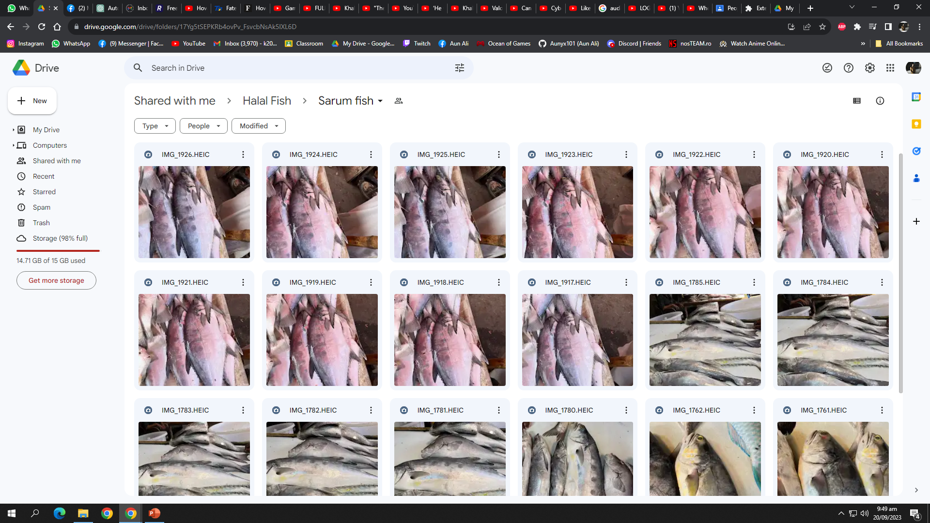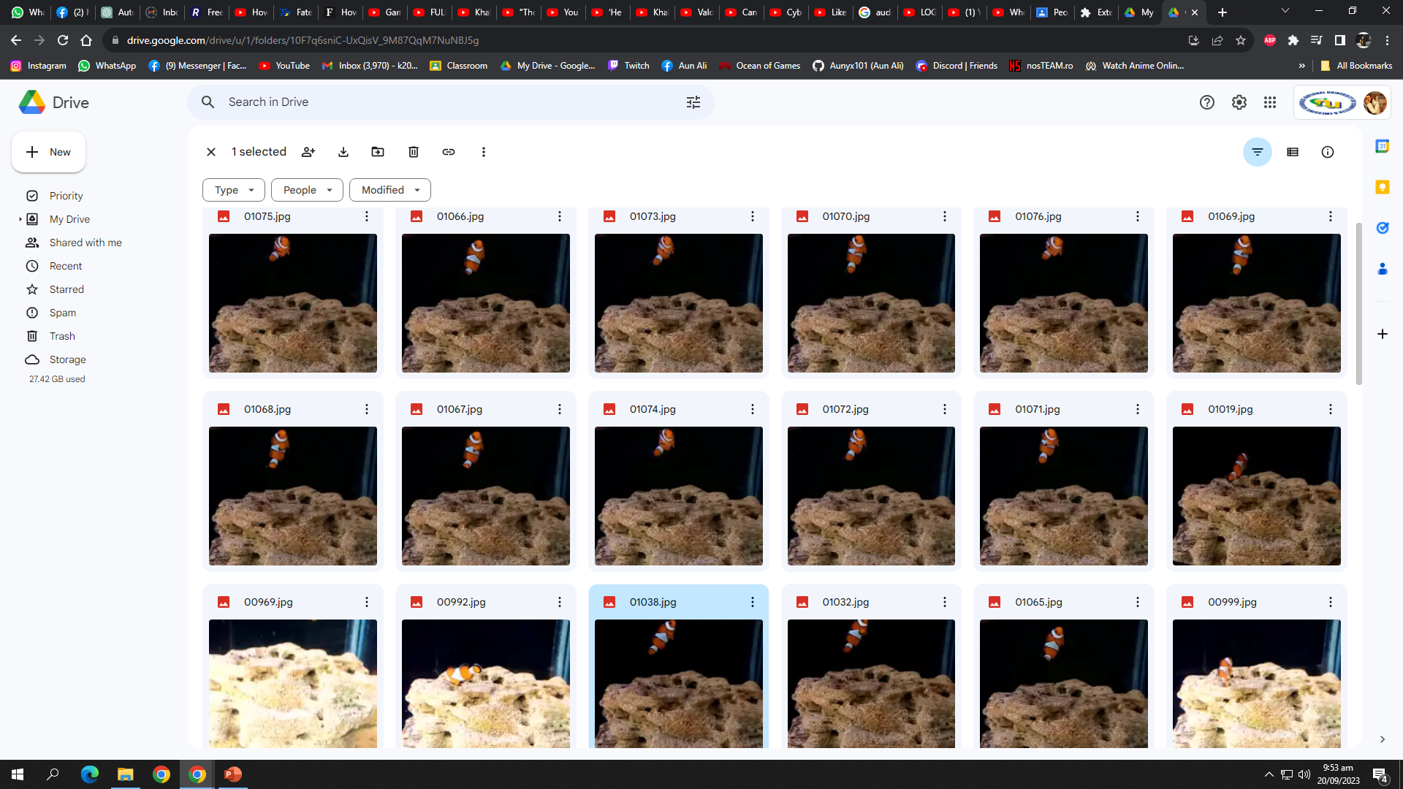

Soil Types:

To gather information on soil types prevalent in different agricultural practices, we visited interior Sindh. These visits involved hands-on exploration of traditional farming practices, providing valuable insights into soil characteristics. Through on-site photography, we documented various soil types, considering factors such as texture, color, and composition. This dataset forms a crucial component of our application's intelligent soil analysis and classification capabilities.

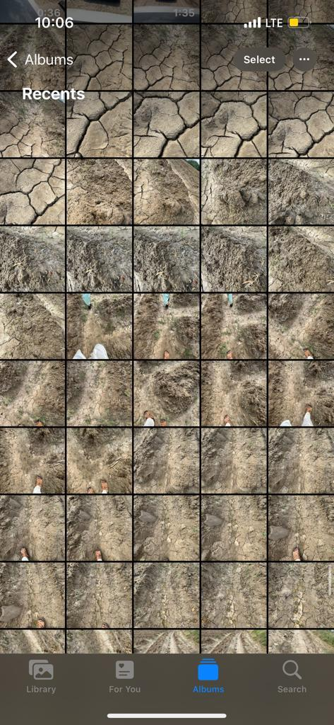

**Code Snippets:**

In the development of our application’s backend model, we employed cutting-edge technologies, including machine learning, computer vision, and artificial intelligence. Below is a brief code snippet showcasing key aspects of the intelligent soil and fish classification system:

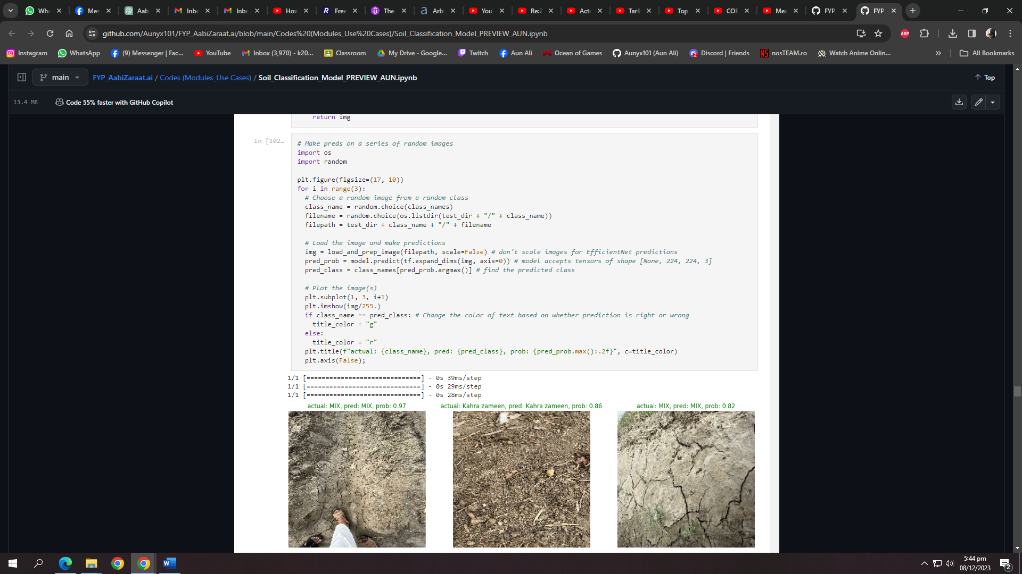

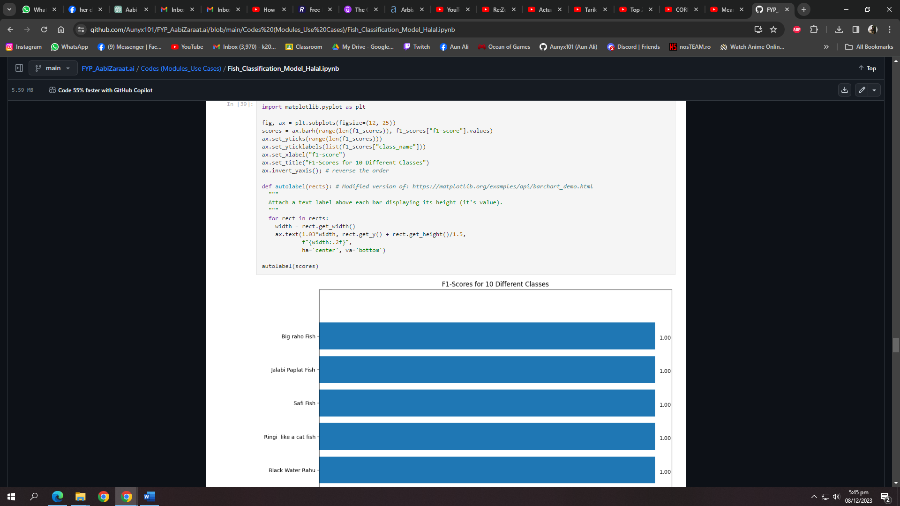

# 6 References & Bibliography

*[1] A. Holzinger et al., "Current Advances, Trends and Challenges of Machine Learning and Knowledge Extraction: From Machine Learning to Explainable AI," in Machine Learning and Knowledge Extraction, Springer, Cham, 2018, pp. 1, DOI: 10.1007/978-3-319-99740-7_1.*

*[2] M. Hassaballah and K. M. Hosny (Eds.), "Recent Advances in Computer Vision: Theories and Applications," Studies in Computational Intelligence, Springer Cham, 2019, pp. XV, 425, DOI:10.1007/978-3-030-03000-1.*

*[3] A. A. Khan, A. A. Laghari, S. A. Awan, "Machine Learning in Computer Vision: A Review," SIS EAI,2021, DOI: 10.4108/eai.21-4-2021.169418.*

*[4] Government of Pakistan, Ministry of Finance, "Pakistan Economic Survey 2020-21," 2021. [Online]. Available:* [*https://www.finance.gov.pk/survey/chapters_21/02-Agriculture.pdf*](https://www.finance.gov.pk/survey/chapters_21/02-Agriculture.pdf)*.*

*[5] M. A. Khan and M. Ahmed, "Review of Available Knowledge on Land Degradation in Pakistan," ICARDA, March 2012.*

*[6]* *"The Impact of Fertilizers on the Environment: Inorganic vs. Organic," Farmerline, June 23, 2023. Available:* [*https://farmerline.co/*](https://farmerline.co/)

*[7] Nation, "Unsustainable farming," The Nation, Jul. 4, 2023. [Online]. Available:* [*https://www.nation.com.pk/04-Jul-2023/unsustainable-farming*](https://www.nation.com.pk/04-Jul-2023/unsustainable-farming)

*[8] IIPS. (2023). "Sustainable Agriculture and Food Security: Boosting Pakistan's Economy." [Online]. Available:* [*https://iips.com.pk/sustainable-agriculture-and-food-security-boosting-pakistans-economy/#:~:text=Soil%20erosion%2C%20salinity%2C%20and%20declining,its%20ability%20to%20support%20crops*](https://iips.com.pk/sustainable-agriculture-and-food-security-boosting-pakistans-economy/#:~:text=Soil%20erosion%2C%20salinity%2C%20and%20declining,its%20ability%20to%20support%20crops)

*[9] H. N. Pahalvi, L. Rafiya, S. Rashid, B. Nisar, and A. N. Kamili, "Chemical Fertilizers and Their Impact on Soil Health," in: First Online: 01 April 2021. DOI: 10.1007/978-3-030-61010-4_1. Available:* [*https://link.springer.com/chapter/10.1007/978-3-030-61010-4_1*](https://link.springer.com/chapter/10.1007/978-3-030-61010-4_1)

*[10] M. A. Khaskheli, "Fertilizers and Environmental Pollution," Agriculture Officer Sanghar. [Online]. Available:* [*https://www.pakissan.com/english/issues/fertilizers.and.environmental.pollution.shtml*](https://www.pakissan.com/english/issues/fertilizers.and.environmental.pollution.shtml)

*[11] M. A. Khaskheli, "Fertilizers and Environmental Pollution," Agriculture Officer Sanghar. [Online]. Available:* [*https://www.pakissan.com/english/issues/fertilizers.and.environmental.pollution.shtml*](https://www.pakissan.com/english/issues/fertilizers.and.environmental.pollution.shtml)

*[12] S. Z. H. Shah, H. T. Rauf, M. I. Ullah, M. S. Khalid, M. Farooq, M. Fatima, S. A. C. Bukhari, "Fish-Pak: Fish species dataset from Pakistan for visual features based classification," Department of Zoology, University of Gujrat, Pakistan; Department of Computer Science, University of Gujrat, Pakistan; Department of Fisheries and Aquaculture, University of Veterinary and Animal Sciences, Lahore, Pakistan; Division of Computer Science, Mathematics and Science, Collins College of Professional Studies, St. John's University, New York, USA.*

*[13] G. Wright, "AI is becoming an 'integral part' of fisheries management and seafood processing," Mar. 20, 2023.*

*[14] M. M. U. Rehman, "Advancements in Fish Farming is a Sustainable Solution for Future Fish Demand," Jun. 22.*

*[15] M. Y. Laghari, "Aquaculture in Pakistan: Challenges and opportunities," Int. J. Fisheries Aquat. Stud., vol. 6, no. 2, pp. 56-59, 2018.*

*[16] S. Abbas, S. Fatima, and M. S. Khattak, "The role of aquaculture in the sustainable development of irrigated farming systems in Punjab, Pakistan," Published online: June 28, 2008. DOI: 10.1046/j.1365-2109.1997.00912.x.*

*[17] I. Ahuja, E. Dauksas, J. F. Remme, R. Richardsen, and A.‐K. Løes, "Fish and fish waste-based fertilizers in organic farming – With status in Norway: A review," Norwegian Centre for Organic Agriculture (NORSØK), Tingvoll, Norway; Department of Biological Sciences, Norwegian University of Science and Technology (NTNU), Ålesund, Norway; SINTEF Ocean, Ålesund, Norway; SINTEF Ocean, Tromsø, Norway, Received May 22, 2020, Revised July 8, 2020, Accepted July 28, 2020, Available online July 28, 2020. DOI: 10.1016/j.wasman.2020.07.025.*

*[18] "AnchoisFert: A New Organic Fertilizer from Fish Processing Waste for Sustainable Agriculture," Published online: March 2, 2022. DOI: 10.1002/gch2.202100141.*

*[19] M. Radziemska, M. D. Vaverková, D. Adamcová, M. Brtnický, and Z. Mazur, "Valorization of Fish Waste Compost as a Fertilizer for Agricultural Use," Original Paper, Published: April 16, 2018, vol. 10, pp. 2537-2545, 2019.*

*[20] M. Khan and C. A. Damalas, "Farmers' knowledge about common pests and pesticide safety in conventional cotton production in Pakistan," Published online: July 14, 2015. DOI: 10.1016/j.cropro.2015.07.014.*

*[21] F. Aldosari, M. Mubushar, and M. B. Baig, "Assessment of farmers knowledge on pesticides and trainings on pesticide waste management in Central Punjab – Pakistan," Journal of Experimental Biology and Agricultural Sciences, vol. 6, no. 1, pp. 168-175, February 2018. DOI: 10.18006/2018.6(1).168.175.*

*[22] M. F. Ali, M. Ashfaq, S. Hassan, and R. Ullah, "Assessing Indigenous Knowledge through Farmers’ Perception and Adaptation to Climate Change in Pakistan," Institute of Agricultural and Resource Economics, University of Agriculture, Faisalabad, Pakistan. Received: August 3, 2017; Accepted: February 10, 2018.*

*[23] S. Fahad, T. Inayat, J. Wang, L. Dong, G. Hu, S. Khan, and A. Khan, "Farmers’ awareness level and their perceptions of climate change: A case of Khyber Pakhtunkhwa province, Pakistan," Published online: 2020. DOI: 10.1016/j.landusepol.2020.104669.*

*[24] A. Memon, "Agriculture: The need to increase farmers’ knowledge," Published: March 20, 2023.*